How to Update Financial Reports to show Current Year Data

My Financial Reports are showing last year’s numbers. How can I change these to the current-year numbers?
This is because the financial report formats are year specific.
Agility allows users to update the “year” for selected financial report layouts. You can also roll existing financial report layouts forward or backward 1 year. This way, you can create a new layout for the NEW year templated off the prior year’s layout.

Two Ways to make this Change
- If you are on Agility v547 or before, and your company does NOT specify the full year on the Layout name, column, and header of the financial report layout, please skip to page 6

- If you are on Agility v547 and after, and your company DOES specify the full year on the Layout name, column, and header of the financial report layout, please skip to page 2

Financial Report Layout Update
This option should be used if you are on Agility v547 and after, and your company DOES specify the full year on the Layout name, column, and header of the financial report layout.

General Ledger > Financial Report Writer > Financial Report Layout Update
The Financial Report Layout Update window allows you to select an existing financial report layout and increase or decrease the years referenced in that layout by 1.
To start, select the layout you want to modify from the dropdown:
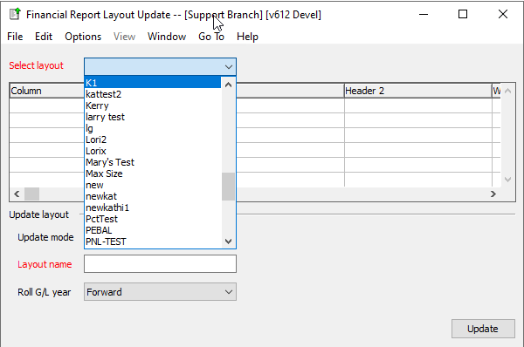

This will populate the layout grid so you can review that layout’s selected columns. From there, decide if you want to “Template new layout” and save the rollover results under a new layout name -OR- “Update existing layout”.
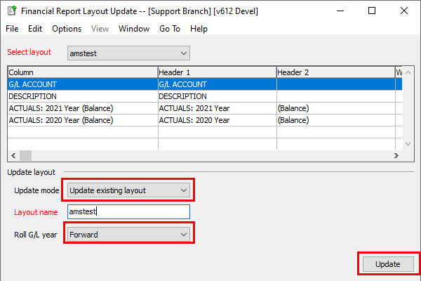
In this example, we elected to update the “amstest” balance sheet layout FORWARD to 2024.

When using the “Update existing layout” update mode, you will receive a prompt cautioning you that your layout will be renamed and no longer available under its old name. (see below) 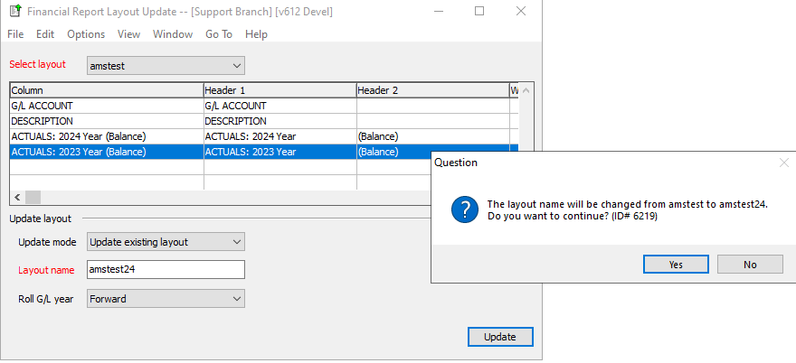
After clicking “Yes”, your layout should be updated to the new years.
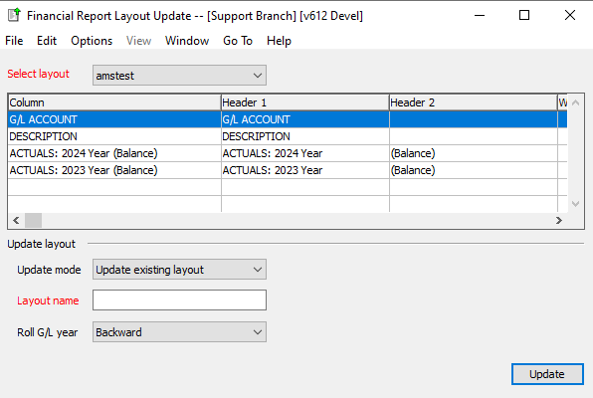

Move Layout Columns Up and Down
General Ledger > Financial Report Writer > G/L Print or Export Financial Reports
Here in this window, the buttons on the right to ‘Move Up’ or ‘Move Down’ will rearrange your highlighted selected column as desired.
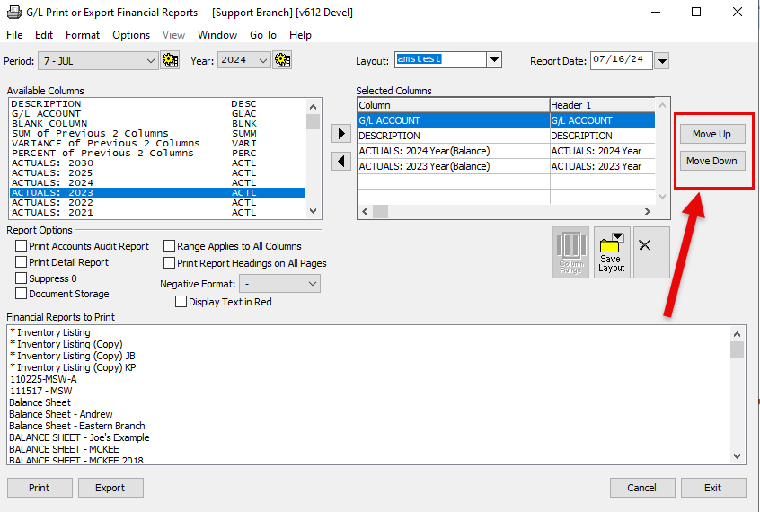
As an example, we have “DESCRIPTION” highlighted in the lower image.
By hitting ‘Move Down’ its relative position will change, positioning it under ‘G/L ACCOUNT’, allowing you to quickly update your financial report column positions with little effort.
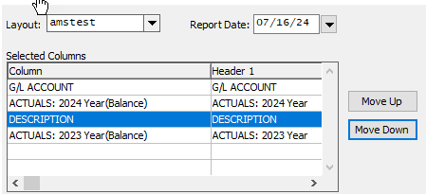

Print or Export Financial Reports
This option should be used If you are on Agility v547 or before, and your company does NOT specify the full year on the Layout name, column, and header of the financial report layout

General Ledger > Financial Report Writer > Print or Export Financial Reports
Choose the first layout you want to update.
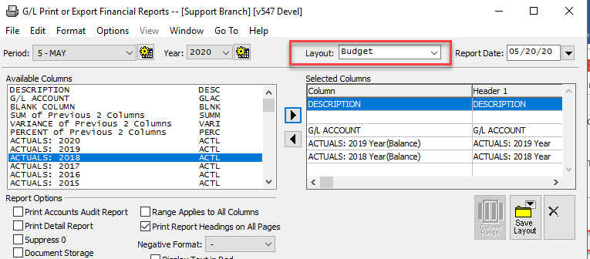

Double click in the Selected Columns on the current column to see what data it is pulling. For the case below, it is looking at the 2019 Actuals, Year Balance.

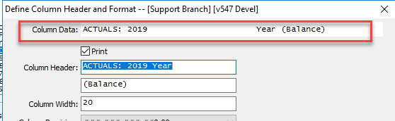

Exit out of this screen. You will want to choose the current year, same Column Data. We will choose 2020 Year Balance. Next, choose Actuals 2020. Then when the periods open, choose the Year (Balance) and click the black triangle pointing to the right to move it into the Selected Columns section.

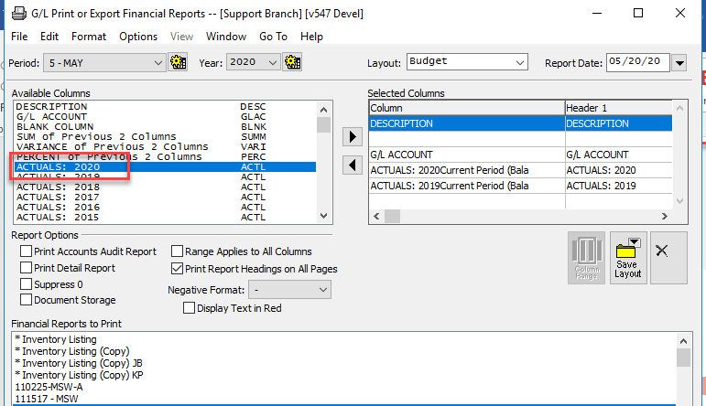

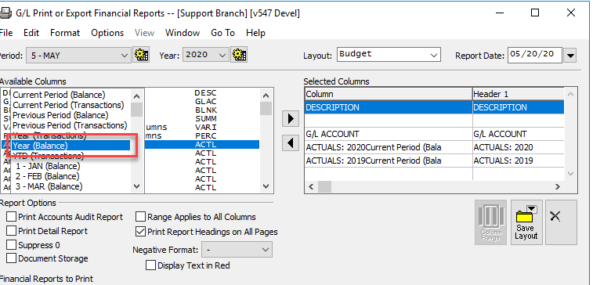
If you have multiple sets of data, continue the above steps until you have added all the correct dates.
Move last year’s data off the “Selected Columns” selection by choosing the line then clicking on the left black triangle.
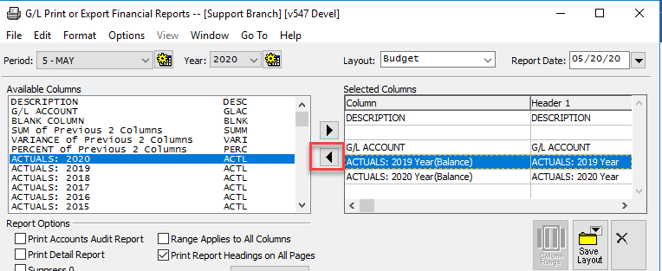
Finally, go to File > Save Layout. Replace the existing report or give it a new name.
Repeat these steps for each of the layouts that you use.

