# What are some Common User Preferences that are set for users?

Some of the more popular Preferences to set are**:**

## Load SO Entry windows in memory at login (Sales Tab)

This value defaults as set and allows users faster access to Sales Order Entry as the windows load into memory when they first login to the system.

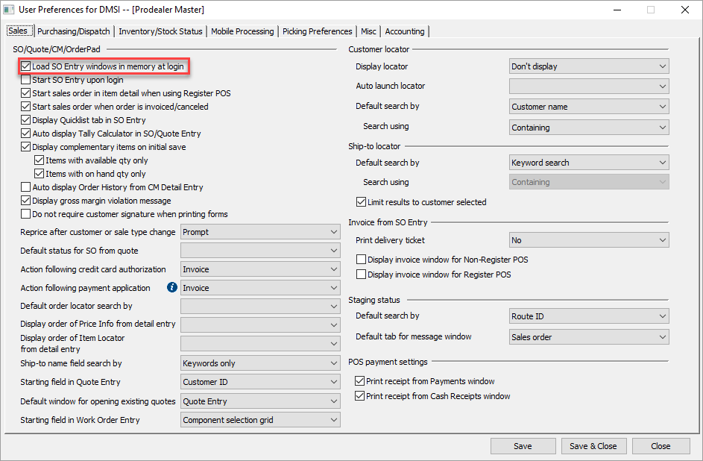

Auto Display Tally Calculator in SO/Quote Entry (Sales Tab)Option to automatically display the Tally Calculator screen to enter tallies for tally calculator items within sales order/quote entry and on the Specify Items to Order screen.

Unset this field if you typically enter tally calculator quantities in BF. You can still access the Tally Calculator screen by selecting the tally calculator icon.

This field has no impact on credit memos.

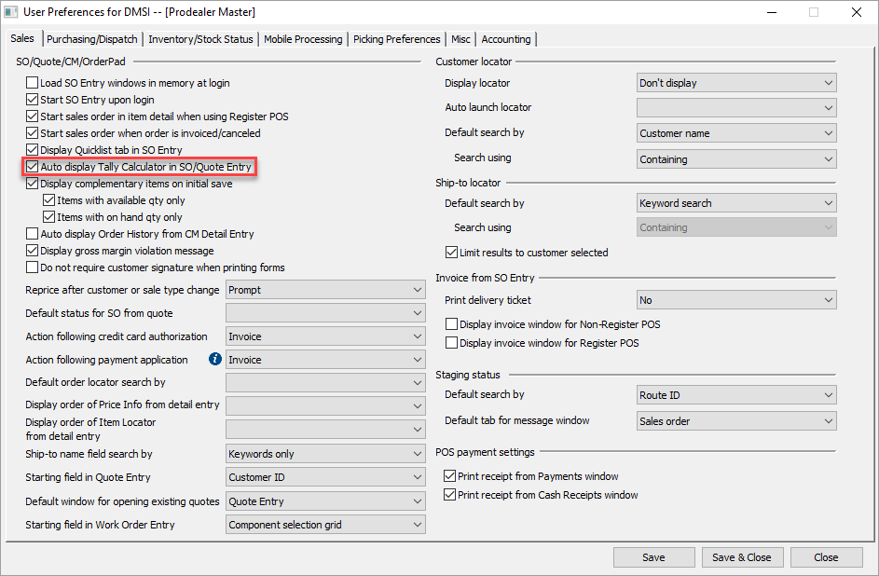

Default Laser Printer (Misc Tab)Default laser printer assigned to the selected form type

If this field is other than blank, the value in this field overrides the default printer defined on the Forms Assignment screen for the form type.

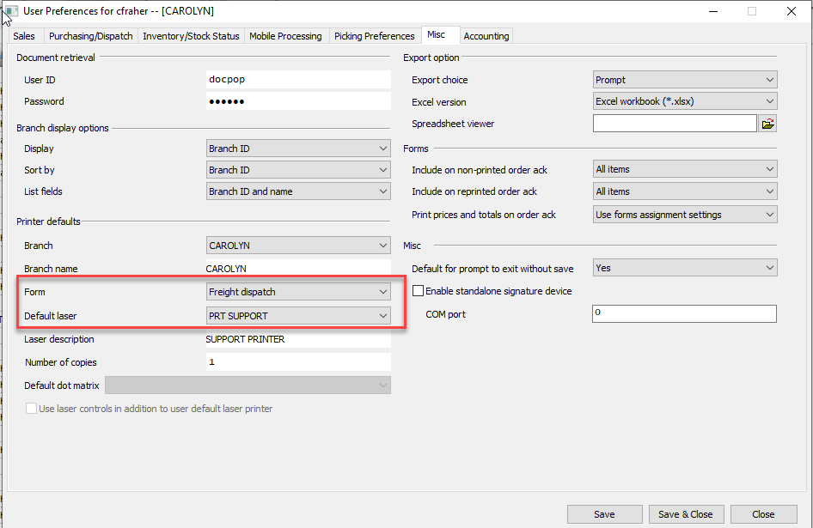

## Form: Invoice, Number of Copies (Misc Tab)

Define this field to more than one copy for POS/Counter users so if your process is for them to invoice counter sale orders and print a copy of the invoice for the customer and one for an office/signature copy.

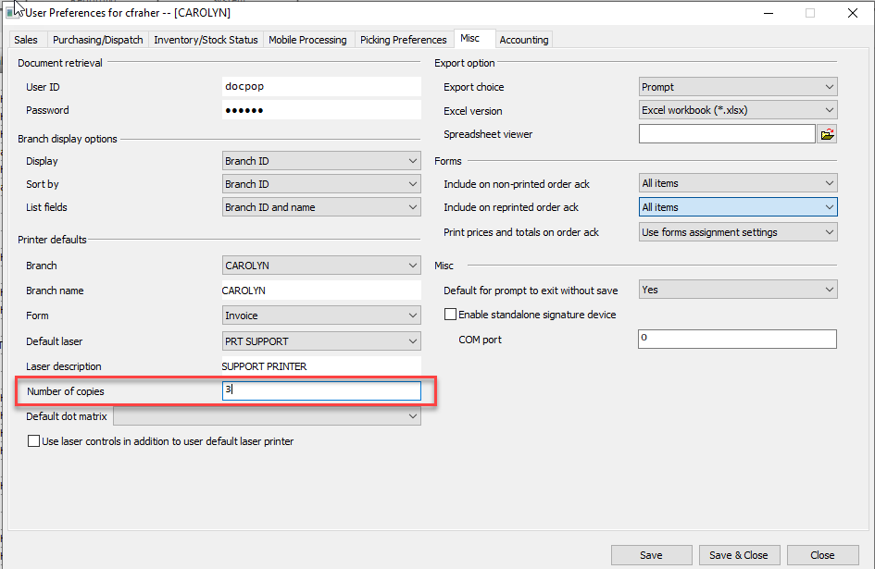

Start SO Entry upon Log-inOption to launch the Sales Order Entry Screen and auto start a new Sales Order upon log-in. This is mainly used for POS/Counter Log-in’s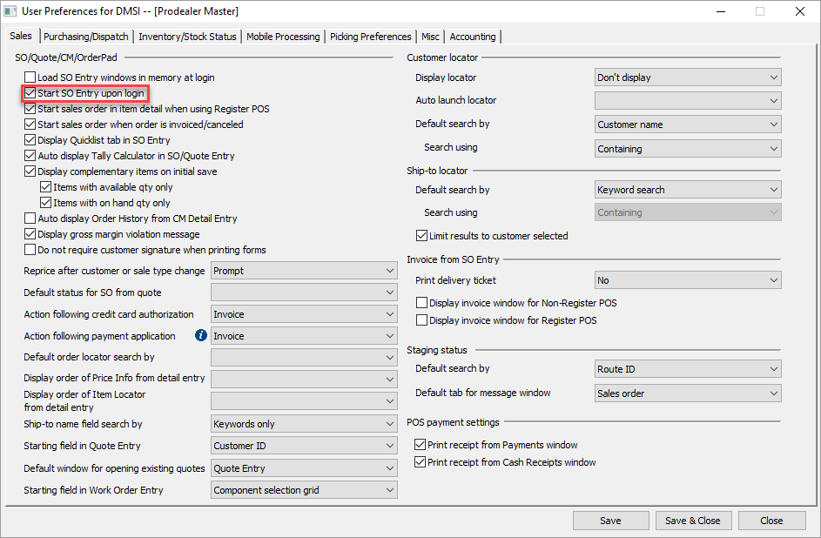

Excel Export VersionVersion of the Excel Software to use when exporting data from Agility to an Excel Spreadsheet. Valid options include both Excel 97-2003 workbook (*.xls) and Excel workbook (*xlsx). This field defaults to the Excel workbook (*xlsx)

The value for hosted customers in the Spreadsheet Viewer field should be G:\FTServer\FTServer.exe

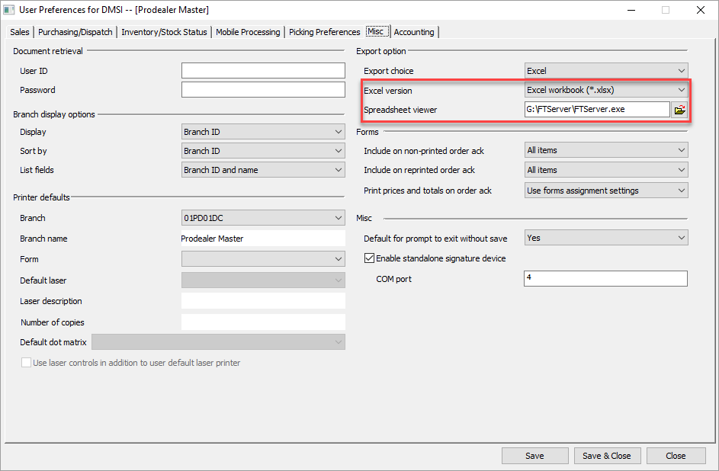

## Ship-to Name Field Search By

Option to search customer keywords when searching from the **Ship-to name** or **Name** field in transaction entry screens.

This field defaults to Keyword only but by switching it to ship-to names and keywords it will allow you to search for the ship-to’s name specifically and if a match isn’t found the system will then search using the same keyword search. 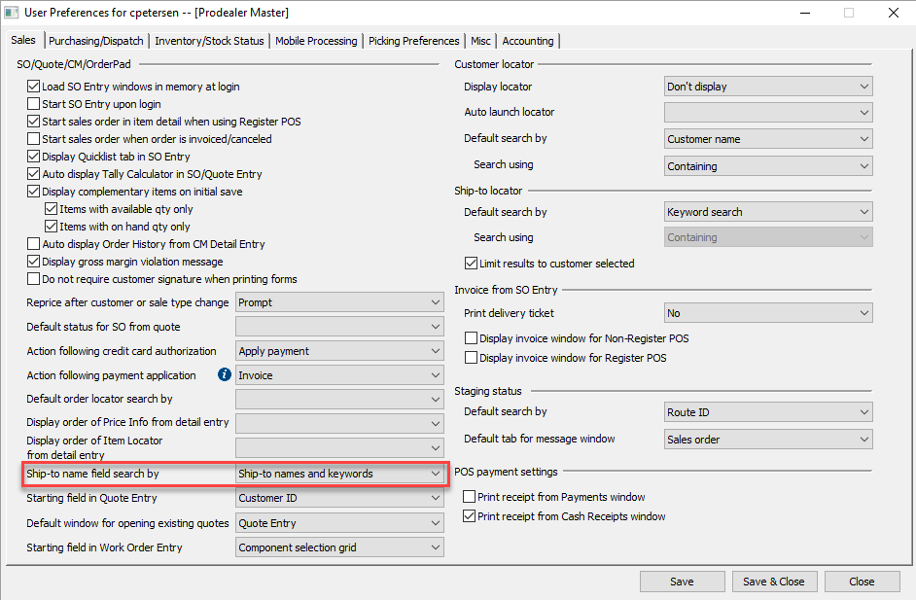

## Default order locator search by

Default **Search and sort by** selection when you initially access the sales order or quote header locator

Useful for inside sales to help refine past order location

