Getting Started as a New System Manager

Utilizing DMSi Portal
- The Portal:
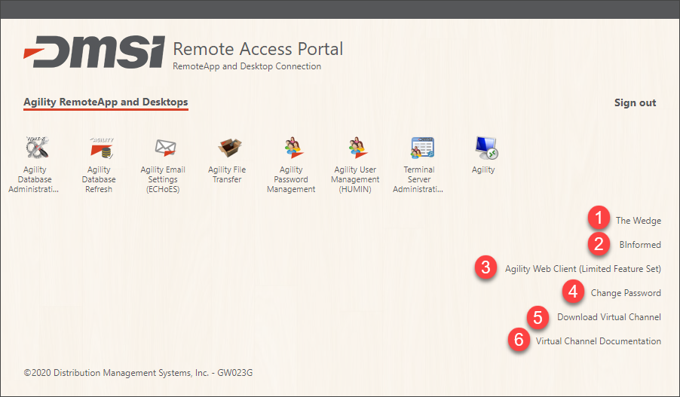
- The Wedge: Users who have access to the Wedge have access to a large amount of resources! Training Videos, Webinars, Ideas, Articles, and Cases!
- BInformed: Users can access the optional BInformed product, which is an interactive business intelligence application for viewing and analyzing your business data.
- Agility Web Client: Allows access to the full Agility desktop and RemoteApp from any HTML5 compatible browser.
- Change Password: User can update/change their password at any time! They can do this before their 90-day password expires.
- Download Virtual Channel: The virtual channel is what allows the user to transfer files from the hosted site to their local computer. It allows users to export to excel and view the Network Connection Monitor.
- Virtual Channel Documentation: Step by step instructions on downloading the Virtual Channel.
- Common reasons why user is getting the VC Client error
  - FT Server path is not listed in Spreadsheet Viewer
    - User preferences (File > User Preferences > Misc tab)
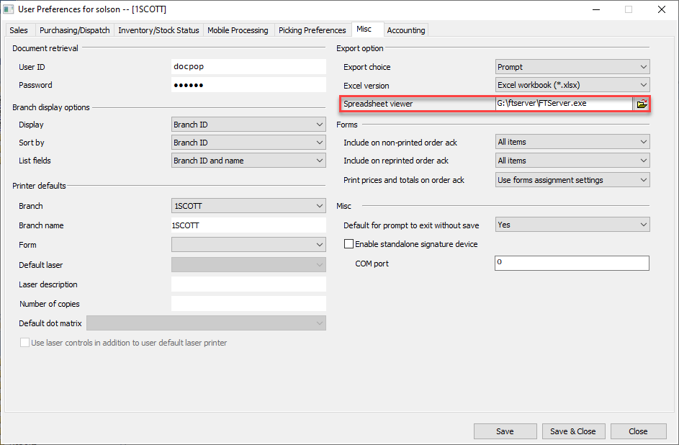
  - Agility VC Client does not have “Load into all mstsc processes” checked
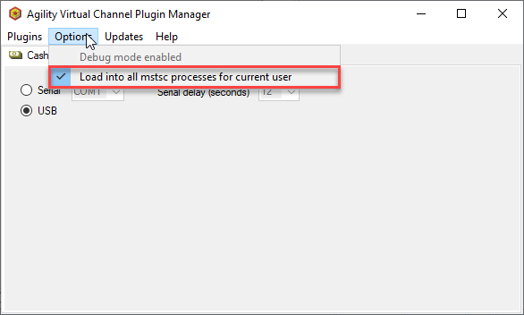

The Wedge
- Creating new users on the Wedge (AR1998)
- How to see Development Projects on the Wedge:
- Go to Releases > Select the specific version:
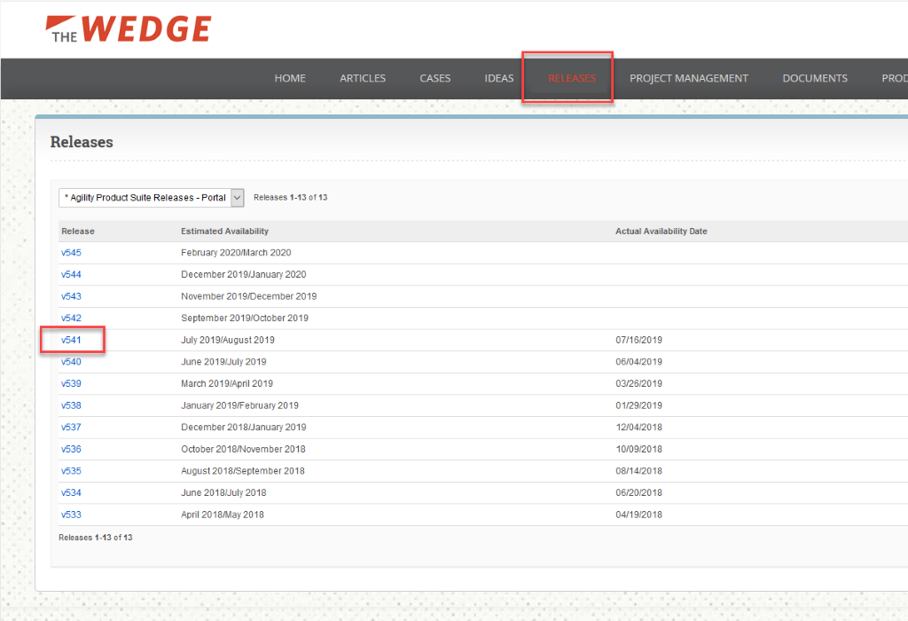
- After you select the specific release, you can see your Projects and their status:
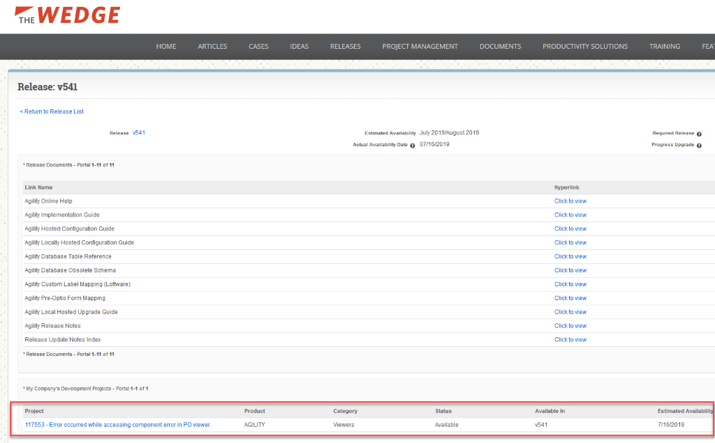
- Finding a CQ Sample:
- Simply go to the Article tab.
- Enter your search criteria.
- Select Search.
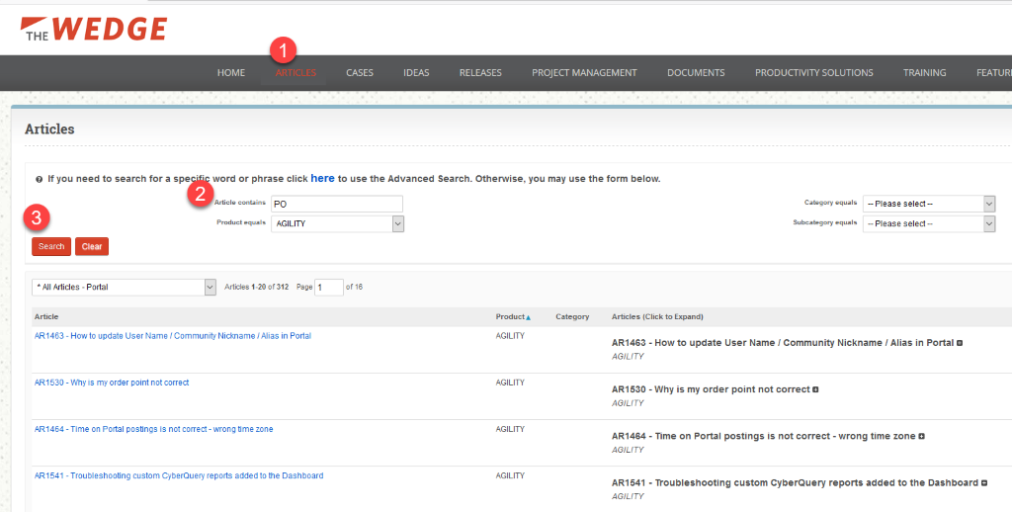
- Select the drop down.
- Select Cyberquery Custom Report Samples.
- Your selection has now narrowed down to CQ samples. You can click open the report, copy the text and paste into VCQ Report Writer in Agility.
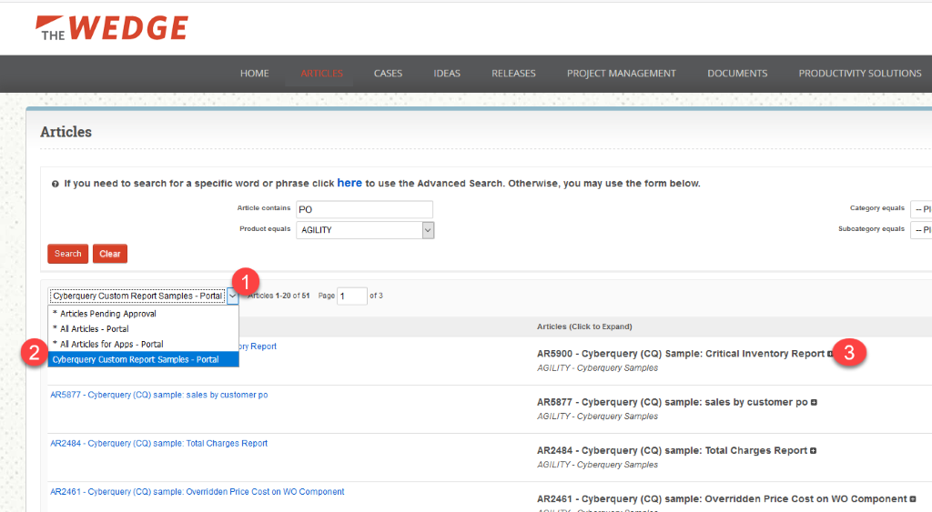
- Ideas on the Wedge:
  - Get others to vote for an idea: This increases the chances of Ideas being incorporated into future releases.
  - Vote on other ideas.
  - Cost Share – Begins a process that lets others know what companies are willing to share the cost of creating a module:
    - When the customer decides that they want to have an idea as a cost share, they can check the box and it will email DMSi which puts the process in motion.
    - The customer is notified that we will take the next steps to figure out the development level to accomplish the idea (and development will prepare a quote).
    - Once the quote has been completed, DMSi contacts the customer to review the details and the price to determine the amount they want to invest upfront. We want the customer who started the cost share process to invest in their own project.
    - The design information will be updated on the Idea along with the dollar amount needed to get on the schedule.
    - As with any other idea, any customers attached to the idea get the updated comment and then can reply with additional comments.
    - Cost shares stay active for roughly 6 months.

Agility Online Help
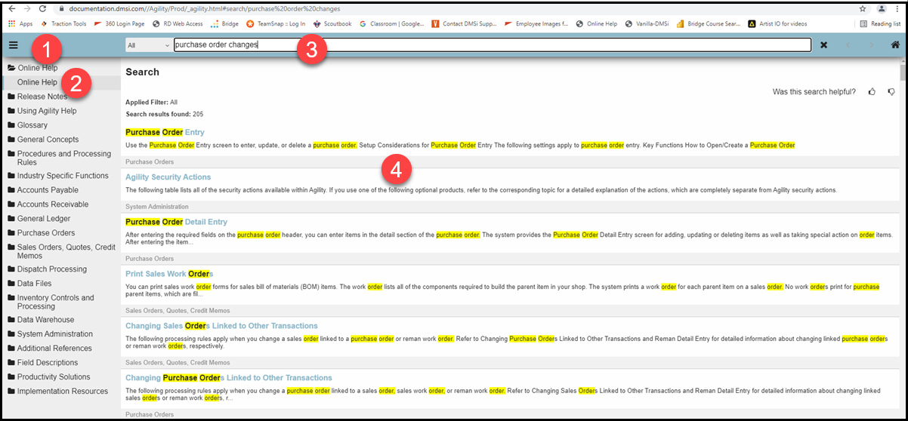
- Menu – collapse or display the contents
- Contents – general information about a module or function. Automatically syncs to the topic displayed for ease in reviewing topics in the same area.
- Search – search using keywords (i.e. “balancing” or “checklist”).
- Results – displays the results of the search, highlighting the specific words searched for, giving an easier way to identify what you need
Access Agility Online Help by hitting F1 on the keyboard from any window in Agility or use the Resources tab > Agility Online Help

Viewers & Reports
- Create Custom Viewers Article (AR1153)
- Recommended/Commonly Used Viewers (Online Help)

Users Experience
- New User Checklist for System Admins (AR21211)
- How to select and lock dashboards (AR19204)
- How to organize recent activity on Agility Dashboard (AR2041)
- How to Edit Sales Order Layouts (AR421)
- How to set up Quick Access Toolbar (AR1154)
- How to set up Menu Favorites (AR1410)
- How to set up Favorites (AR1409)
- How to set up User Preferences (AR2097)

Utilizing Support
- Email: support@dmsi.com
- Phone: 800-347-6720, option #1 or 402-330-6620, option #1
- The Wedge
- Monday thru Friday 8:00am – 5:00pm Central Standard Time
- When submitting a case, provide as much detail as you can. The Who, What, When, Where, Why, and How. This helps us troubleshoot and get an answer back to you quicker
  - Who was the user? Is it happening to all users or one user? Is it 1 transaction or all transactions? Is it one branch or all branches?
  - What were they trying to do? What were you expecting the result to be?
  - When did it happen? How often does it happen?
  - Which window were you in Agility?
  - How did it happen? What steps did you user take?

