# Daily Balancing in Agility

Recommended only for versions pre 545; for versions after 545 DMSi recommends using [AR19378 - How to set up GL Recon in Agility](https://360.dmsi.com/prod1/portal/portal.jsp?c=5899&p=109533894&g=109534381&id=123460760)

Dmsi recommends a daily balancing process to ensure the Default accounts in Agility are staying in balance with sub-ledgers. This would include, AR Trade, AP Trade, AP Clearing/Recon, Inventory, Sales, and COGS. The four steps included in this article are 1) manual daily balancing 2) automated daily balancing 3) filling out the daily balancing worksheet and 4) common out of balance issues.

## Manual daily balancing

These are the manual steps for running the daily balancing. You can save the balances with the [Daily Balancing Worksheet](https://360.dmsi.com/prod1/portal/portal.jsp?c=5899&p=109533894&g=109534157&id=104463138).

Here is the link to the [Day End Procedures Checklist](http://documentation.dmsi.com/agility/prod/Additional_References/dayendprocedureschecklist.htm).

At the end of each day you will want to do the following for Daily Balancing:

1. Run the Data Warehouse *(Data Warehouse > Update DW)*

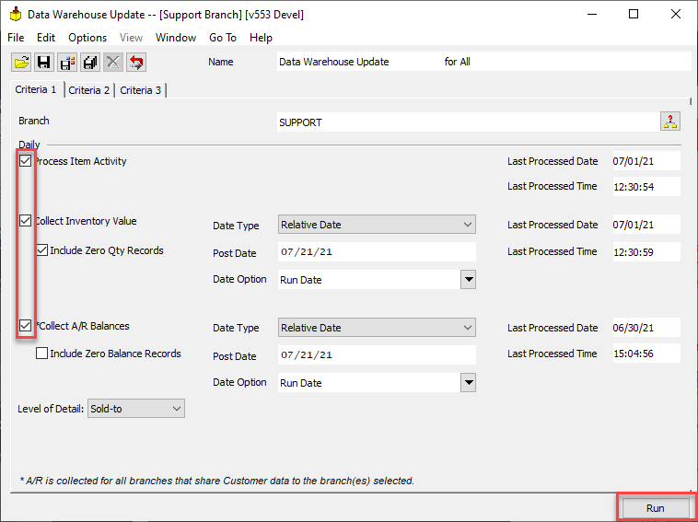

* **The Data Warehouse will take 1-2 minutes to run and will let you know when it is complete. You must run the DW before running your reports.**

1. Run the Subsidiary Balancing Report (*General Ledger > Reports > GL Subsidiary Balancing Reports*). Make sure your Report type is "Subsidiary". You will just need to hit “print” and the report will print to your screen. From there you can email the report to yourself, save it or print a hard copy.

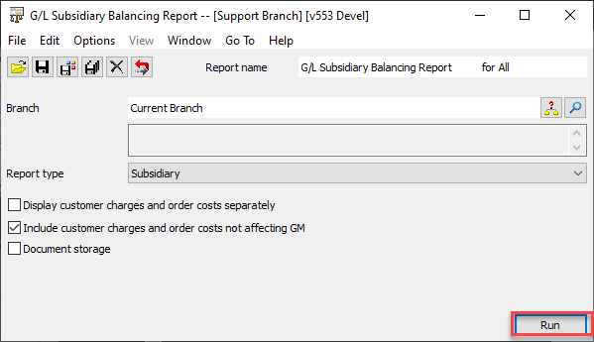

1. Run the GL Comparison Report (*General Ledger> Reports > GL Subsidiary Balancing Reports*). Make sure your Report type is "G/L Comparison". You will just need to hit “print” and the report will print to your screen. From there you can email the report to yourself, save it or print a hard copy.

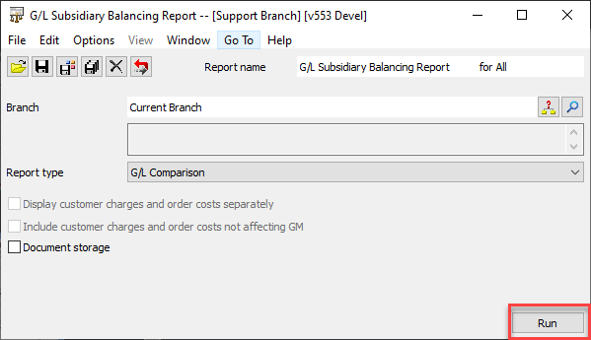

**Please Note: These 3 step paths can be saved in your Favorites.**

## Automate daily balancing

Automating daily balancing will allow you to have the reports run automatically and be emailed nightly.

### Data Warehouse Update

1. Open the Data Warehouse Update *(Data Warehouse > Update Data Whse)*
2. Select All branches, then set your DW Update to Process Item Activity, Collect Inventory Value and Collect A/R Balances
3. Click the Save Criteria For All button, then Save the name (commonly Called Data Warehouse Update)

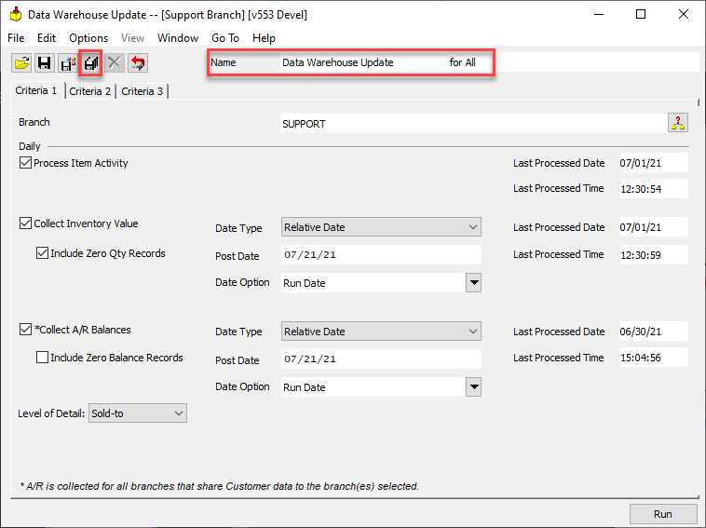

### Subsidiary Balancing Report

1. Open the Subsidiary Balancing Report (*General Ledger > Reports > GL Subsidiary Balancing Reports*). Make sure the Report type is Subsidiary.
2. Click the Save Criteria for All button, then Save the name (commonly called G/L Subsidiary Balancing Report)

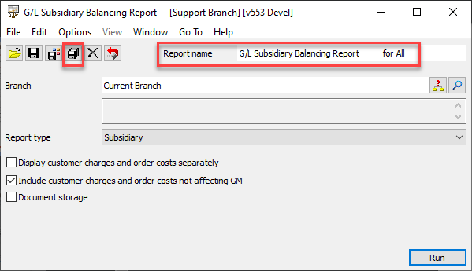

### G/L Comparison Report

1. Open the GL Comparison Report (*General Ledger > Reports > GL Subsidiary Balancing Reports*). Make sure the Report type is G/L Comparison.
2. Click the Save Criteria for All button, then Save the name (commonly called G/L Comparison Balancing Report)

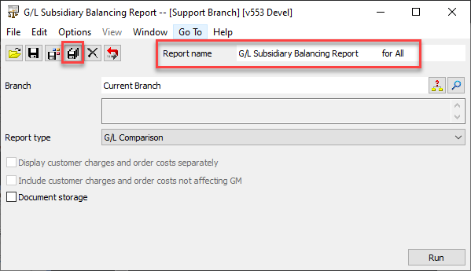

### Automated Processing

Go into Automated Processing (*System Administration > Restricted Processing > Automated Processing > Queue Maintenance)*

1. Click the Create Job button
2. Type in the Job Name (commonly Daily Balancing Reports)
3. Type in the Job description
4. Click the Add Task Icon

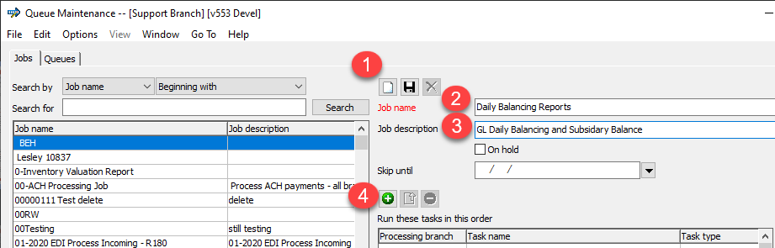

1. Choose the Task Category of Update Process
2. Choose the Process Type of Data Warehouse Update
3. Choose the Process Name that you saved in the Data Warehouse Update section
4. Click OK

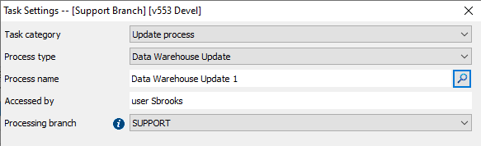

1. Data Warehouse Update has now been added as a task.
2. Click the Add task button again
3. Choose the Task category of Standard Report
4. Choose the Report type of G/L Subsidiary Balancing Report
5. Choose the Report name you saved in the Subsidiary Balancing Report section
6. In the Report data type, choose either PDF or Excel spreadsheet
7. In the ‘Sent to’ addresses section, type each email address the report should get sent to with a comma separating multiple emails
8. Click OK
9. The Subsidiary Balancing Report has been added to the Job

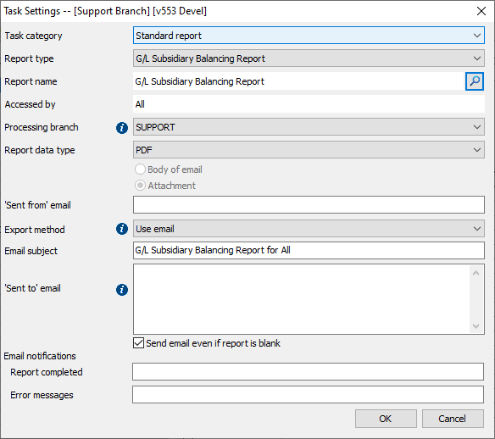

1. Click the Add task button
2. Choose the Task category of Standard Report
3. Choose the Report type of G/L Subsidiary Balancing Report
4. In the Report name field, type in the name you saved in the GL Comparison Report section
5. In the Report data type, choose either PDF or Excel spreadsheet
6. In the Email subject type in “GL Comparison Report”
7. In the ‘Sent to’ addresses section, type each email address the report should get sent to with a comma separating multiple emails
8. Click OK

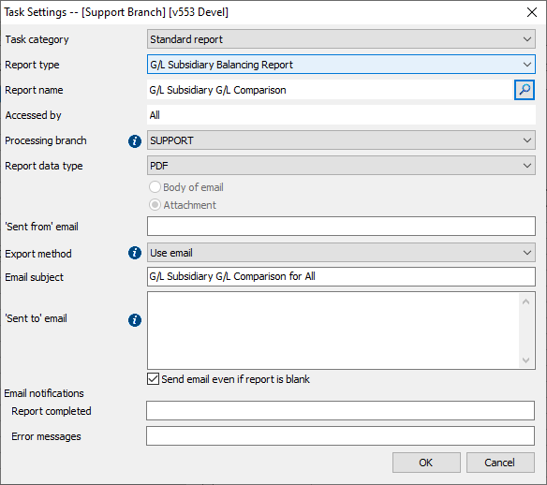

1. On the Jobs screen, click Save
2. Click the Create Queue icon
3. In the Queue name, type in a name (commonly Daily Balancing Reports)
4. In the Frequency field, choose Daily
5. In the Daily interval field, choose Once Daily
6. In the Start time field, choose the time. This is a military value so 8:00 pm is 20:00
7. Click the Add Job icon
8. In the Job locator, search for the Job you just created. Once you find it, click OK.
9. Click the Save Queue icon
10. Your reports will now run nightly assuming the Automated Processing Client is running

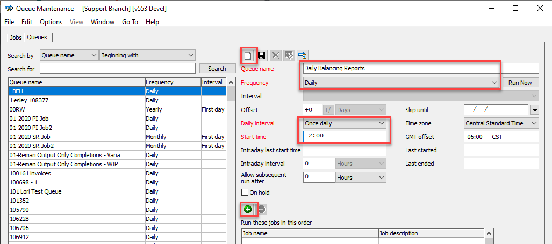

## Enter values into the Daily Balancing Worksheet

1. Enter your balances from each report into your Daily Balancing Excel file. There is a “section” for each of the AR, AP, AP Recon, Inventory, Sales, COGS and Invalid Postings.
2. Enter the date (step 1).
3. For each “section” you will put the balances from the Daily Balancing report (step 2) in the first column of the “section”
4. Put in the balances from the Subsidiary report (step 3) in the second column of the “section.”
5. Step 4 shows the file is formatted to calculate the differences between the Daily Balancing report and the Subsidiary report.
6. Step 5 shows the change in variance from the prior day.

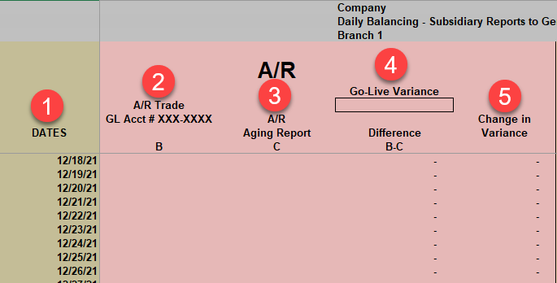

## Common Out of Balance Issues

For out of balances, please see the following Help links to get you started and assist in investigating. You can also search for “balancing” in the [Agility Online Help](http://documentation.dmsi.com/agility/prod/Agility_Online_Help/onlinehelp.htm).

[For Balancing Reports](https://documentation.dmsi.com/agility/prod/_agility.html#page/General_Ledger/g.lbalancingreports.htm) (step 9):

[For Period End Balancing](https://documentation.dmsi.com/agility/prod/_agility.html#page/General_Ledger/periodendbalancing.htm) (step 2):

And other Balancing help docs.

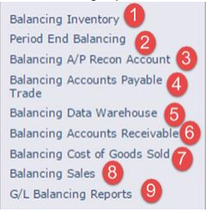

The following are common errors that cause out-of-balance entries:

1. AP and/or AR parameters set to manual post, but transactions have not been posted to the GL
2. Reports were not printed at the same time
3. Backdating transaction such as invoices and receivers
4. Posting both debit and credit side of payables and/or receivables to the same account
5. Dropping A/P Recon records and using the A/P Clearing account as the offset
6. Inventory adjustment reason codes set to post to the Inventory account which will leave a net impact on the GL of zero, while increasing/decreasing the on hand value report.
7. Sales account parameters set incorrectly