How to change or update user passwords in the portal

This article is to walk a system manager through changing or resetting their users’ passwords using the Hosted User Management Tool.
- Login to hosting.dmsi.com
- Enter your admin.xxx for your company. Ex. dmsi\admin.dmsi
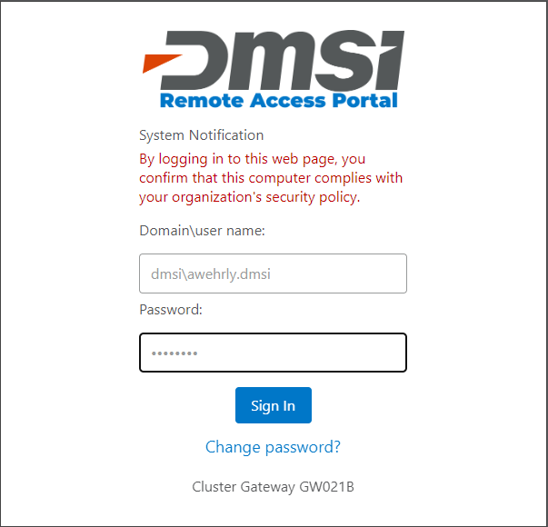
- Launch the Agility User Management (HUMIN) tool by clicking the icon. Click the remote app icon in the bottom left corner to launch the service.
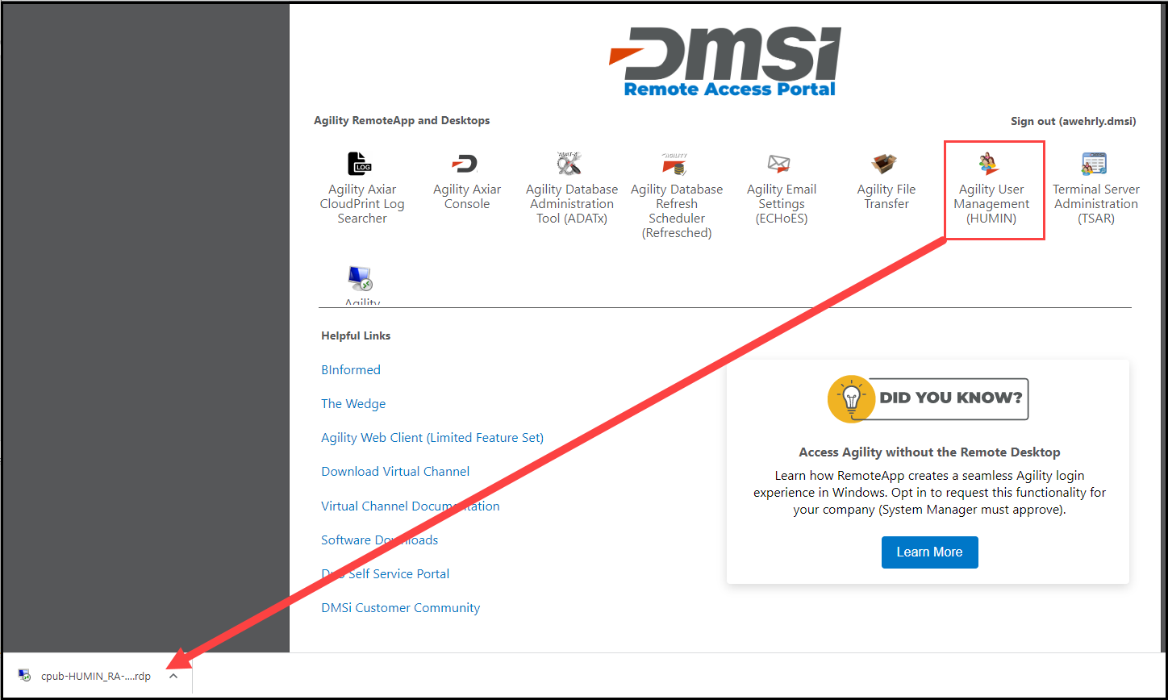
- Click Connect on the RemoteApp screen. Enter your hosted site credentials.
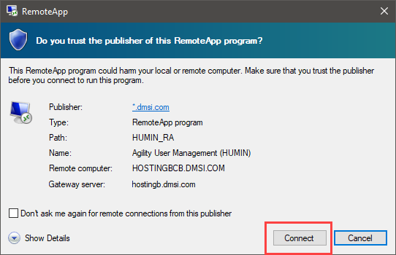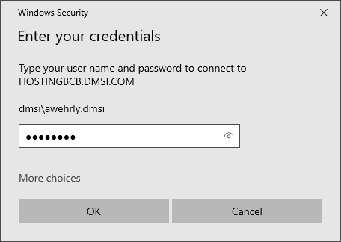
- When HUMIN opens, select the user you would like to update.
- Right click the user (or click Actions) and navigate to Set User(s) Password.
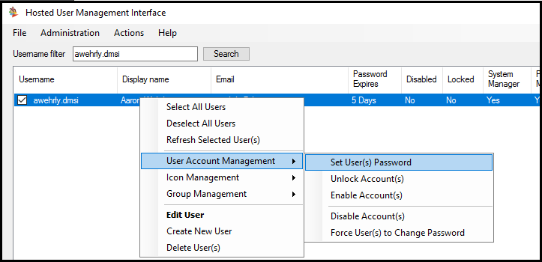
- You will be prompted to enter a password for the user. The requirements must be met to change the password.
- Enter a password for the user and select OK.
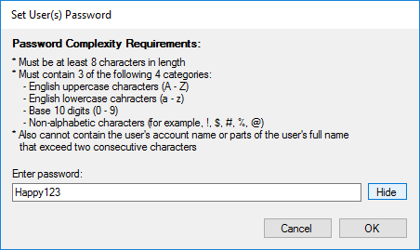
- The user will need to log in using the new password that was specified.

