# How to setup Automated Processing Jobs in Agility

The Automated Processing tool, also known as Auto Processing, allows you to run routine Agility processes automatically without user intervention. The example we will use will be to setup your reorder calculations to be run each month.

## Setting Up Jobs

Go to System Administration > Restricted Processing > Automated Processing > Queue Maintenance.

Click the New Job icon. In Job name, type in Reorder Calculations Forward. Type in the Job description.

Click the Add Task button.

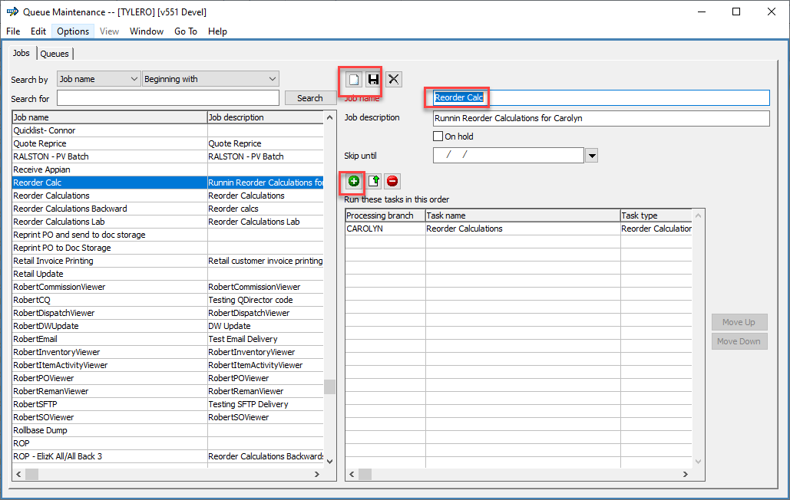

Under Task Category, choose Update Process. The Process Type will be Reorder Calculations. Under the Process Name, click the magnifying glass to open the saved Reorder Calculations you just set up. Choose the first Forward Calculation that was set up and click OK. Verify the processing branch is correct and click OK.

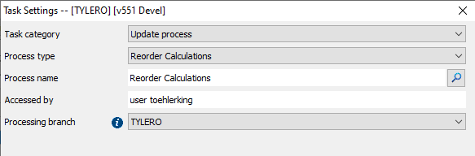

When finished, click the Save Job button.

## Setting up a Queue

Click on the Queue tab. Click on the Create Queue tab. In the Queue Name, type in Reorder Calculations Forward. For Frequency, choose Monthly. In the Interval, choose Last day of calendar month. Your Daily interval will be Once daily. Set the Start time sometime after the end of business. Start time is in military hours, so 6 pm would actually be 18:00. Click Add Job and choose your Job of Reorder Calculations Backward. When finished, click the Save Queue button.

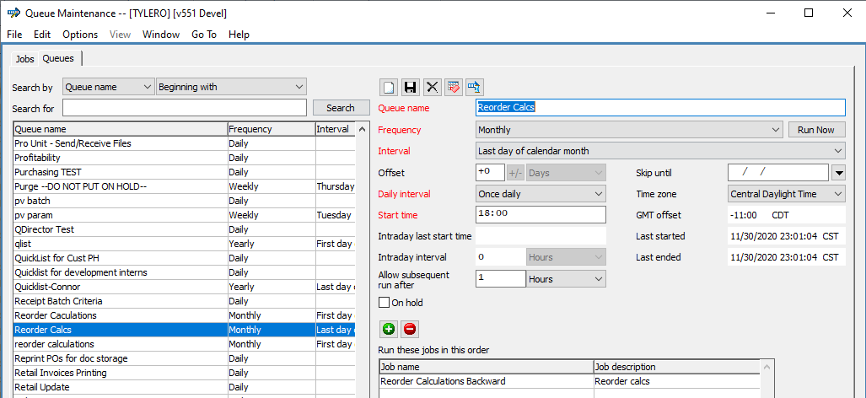

Agility will run the jobs automatically at the times specified.

Listed below are tasks that can be run via automated processing:

|  |  |  |  |  |  |
| --- | --- | --- | --- | --- | --- |
| Custom Cyberquery reports | |  |  | | --- | --- | | • | Automated processing supports scheduling reports with .eq and .mf extensions. If the report query cannot be located or if the report will not compile due to a syntax error, the system sends an email that the report task failed. | | • | To email the report output, define the output format (such as PDF or .xls) on the Automated Processing job task. If there is no output format defined, automated processing emails the file with the .cqe extension. | |
| External Interface | |  |  | | --- | --- | | • | [A/R ACH Processing](http://documentation.dmsi.com/agility/prod/Accounts_Receivable/a.rachprocessing.htm) | | • | [Billtrust Invoice](http://documentation.dmsi.com/agility/prod/Productivity_Solutions/billtrustinterface.htm) |  |  |  | | --- | --- | | • | [Billtrust Statement](http://documentation.dmsi.com/agility/prod/Productivity_Solutions/billtrustinterface.htm) | | • | [Send/Receive EDI Files](http://documentation.dmsi.com/agility/prod/Productivity_Solutions/send.receivefiles.htm) |  |  |  | | --- | --- | | • | [Process Incoming EDI Files](http://documentation.dmsi.com/agility/prod/Productivity_Solutions/processincomingfiles.htm) | | • | [Process Millwork Development Orders](http://documentation.dmsi.com/agility/prod/System_Administration/millworkdevelopmentinterface.htm) |  |  |  | | --- | --- | | • | [Process TMS Cost Packets](http://documentation.dmsi.com/agility/prod/Productivity_Solutions/transportationmanagementsystemcostpacketinterface.htm) | | • | Routing – Export Final File |  |  |  | | --- | --- | | • | Routing – Export Preliminary File | |
| Forms | |  |  | | --- | --- | | • | [Acknowledgments](http://documentation.dmsi.com/agility/prod/Sales_Transactions/printorderacknowledgments.htm) |   This automated process emails/faxes order and/or credit acknowledgments based on the customer ship-to or customer branch ship-to laser control settings.   |  |  | | --- | --- | | • | [Invoices](http://documentation.dmsi.com/agility/prod/Accounts_Receivable/printinvoiceform.htm) |   This automated process prints/emails/faxes invoices, finance charge invoices, and credit memos based on saved criteria settings in the Print Invoices window.   |  |  | | --- | --- | | • | [Billtrust Account Statements](http://documentation.dmsi.com/agility/prod/Productivity_Solutions/billtrustinterface.htm) |   This automated process generates xml files for account statements based on criteria saved on the Print Account Statements with a setting of Process via Billtrust. This option is only available if your system is licensed and active for the Billtrust Interface. |
| Standard reports | |  |  | | --- | --- | | • | [A/P Aged Open Payables Report](http://documentation.dmsi.com/agility/prod/Accounts_Payable/a.pagedopenpayablesreport.htm) | | • | [A/P Recon Register](http://documentation.dmsi.com/agility/prod/Accounts_Payable/a.preconregister.htm) |  |  |  | | --- | --- | | • | [A/R Aged Trial Balance Report](http://documentation.dmsi.com/agility/prod/Accounts_Receivable/a.ragedtrialbalancereport.htm) | | • | [A/R Lien Reminder Report](http://documentation.dmsi.com/agility/prod/Accounts_Receivable/a.rlienreminderreport.htm) |  |  |  | | --- | --- | | • | [A/R Tax Summary/Detail Report](http://documentation.dmsi.com/agility/prod/Accounts_Receivable/a.rtaxsummary.detailreport.htm) | | • | [Cash Drawer Balancing and Payments](http://documentation.dmsi.com/agility/prod/Sales_Transactions/cashdrawerbalancingandpayments.htm) |  |  |  | | --- | --- | | • | [G/L Subsidiary Balancing Report](http://documentation.dmsi.com/agility/prod/General_Ledger/g.lsubsidiarybalancingreport.htm) | | • | [Inventory Valuation Report](http://documentation.dmsi.com/agility/prod/Inventory_Control/inventoryvaluationreport.htm) |  |  |  | | --- | --- | | • | [Potential Stock Outage Report](http://documentation.dmsi.com/agility/prod/Purchase_Orders/potentialstockoutagereport.htm) | | • | [Sales Analysis Report](http://documentation.dmsi.com/agility/prod/Data_Warehouse/salesanalysisreports.htm) |  |  |  | | --- | --- | | • | [SO Profitability Report](http://documentation.dmsi.com/agility/prod/Sales_Transactions/salesprofitabilityreport.htm) | | • | [Inventory Usage/Purchase Comparison Report](http://documentation.dmsi.com/agility/prod/Inventory_Control/inventoryusage.purchasecomparison.htm) | |
| Update processes | |  |  | | --- | --- | | • | [A/R Finance Charge Application](http://documentation.dmsi.com/agility/prod/Accounts_Receivable/financecharge.htm) | | • | [ABC Classification](http://documentation.dmsi.com/agility/prod/Data_Files/abcclassification.htm) |  |  |  | | --- | --- | | • | [Automated purges](http://documentation.dmsi.com/agility/prod/System_Administration/automatedpurges.htm) | | • | [Batch criteria](http://documentation.dmsi.com/agility/prod/Sales_Transactions/batchcriteria.htm) |  |  |  | | --- | --- | | • | [Cost mass update](http://documentation.dmsi.com/agility/prod/Data_Files/costmassupdate.htm) | | • | [Create pick file](http://documentation.dmsi.com/agility/prod/Sales_Transactions/two.steppickingprocess.htm) |  |  |  | | --- | --- | | • | [Customer item quicklist](http://documentation.dmsi.com/agility/prod/Sales_Transactions/customeritemquicklistcriteria.htm) | | • | [Data warehouse update](http://documentation.dmsi.com/agility/prod/Data_Warehouse/datawarehouse.htm) |  |  |  | | --- | --- | | • | [KPI update](http://documentation.dmsi.com/agility/prod/General_Concepts/keyperformanceindicators.kpis..htm) | | • | [Post unposted activity](http://documentation.dmsi.com/agility/prod/General_Ledger/posting.htm) |  |  |  | | --- | --- | | • | [Reorder calculations](http://documentation.dmsi.com/agility/prod/Purchase_Orders/reordercalculations.htm) | | • | [Shipment update](http://documentation.dmsi.com/agility/prod/Procedures_Processes/shipmentupdatecriteria.htm) |  |  |  | | --- | --- | | • | [Tax interface invoice error processing](http://documentation.dmsi.com/agility/prod/Productivity_Solutions/avalarataxinterface.htm) | | • | [Transaction Analysis](http://documentation.dmsi.com/agility/prod/Sales_Transactions/transactionanalysis.htm) |  |  |  | | --- | --- | | • | [WMS monitor](http://documentation.dmsi.com/agility/prod/Productivity_Solutions/warehousemanagementsystem.wms..htm) | |
| Viewer | |  |  | | --- | --- | | • | [Commission Viewer](http://documentation.dmsi.com/agility/prod/Procedures_Processes/commissionviewer.htm) | | • | [Dispatch Viewer](http://documentation.dmsi.com/agility/prod/Procedures_Processes/dispatchviewer.htm) |  |  |  | | --- | --- | | • | [Inventory Viewer](http://documentation.dmsi.com/agility/prod/Procedures_Processes/inventoryviewer.htm) | | • | [Item Activity Viewer](http://documentation.dmsi.com/agility/prod/Procedures_Processes/itemactivityviewer.htm) |  |  |  | | --- | --- | | • | [PO Viewer](http://documentation.dmsi.com/agility/prod/Procedures_Processes/purchaseorderviewer.htm) | | • | [Reman Viewer](http://documentation.dmsi.com/agility/prod/Procedures_Processes/remanviewer.htm) |  |  |  | | --- | --- | | • | [SO Viewer](http://documentation.dmsi.com/agility/prod/Procedures_Processes/salesorderviewer.htm) |   These automated process emails viewer results in .csv format based on the viewer's saved criteria. |